Eloise Butler Wildflower Garden & Bird Sanctuary Theodore Wirth Beach Parking Lot

Directions and Parking Information

Directions

From I-394: Exit I-394 at Penn Ave and follow Penn Ave north. Turn left at Glenwood Ave. The Theodore Wirth Beach Parking Lot will be on the right.

From Hwy 100: Exit Hwy l00 at Glenwood Ave. Turn left on Glenwood Ave. The Theodore Wirth Beach Parking Lot will be on the left.

From Hwy. 55: From Hwy 55 turn south onto Theodore Wirth Parkway. Turn left one Glenwood Ave. The Theodore Wirth Beach Parking Lot will be on the left.

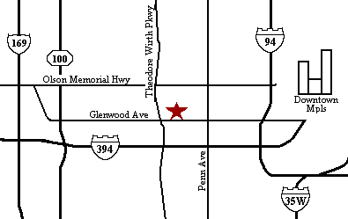

Parking:
Buses are permitted to park in the Theodore Wirth Parking Lot free of charge.

A Garden Naturalist will meet you at the Parking Lot to walk your group along park trails into the Garden.

